|  |
| --- |
| Victoria State Accident Software Report Executive Summary |
| Cooper Mitchell s5185611, Thomas Jensz s50998282810ICT Software TechnologiesOctober 11, 2020 |

# Abstract

This report demonstrates the functionality of the Victorian Traffic Accident Data Analysis system by analyzing the crash data in 2018. The findings present that 2018 was an average year for road crashes in Victoria. Crashes in the dark were found to be much more frequent and result in more unpredictable injuries. When drivers had passengers in their car, more crashes occurred. These statistics could be very beneficial to legislation in the state.

# Introduction

The purpose of this report is to present the results of the data analysis from the Victoria State accident software. To demonstrate the abilities of the software, a 12-month period of data was selected and analyzed. The date range selected is the year of 2018 (1st January 2018 – 31st December 2018). Each function that the software can perform will be analyzed using the dataset in the chosen date range. The analysis tasks are: Display all crash data from 2018, The relationship between alcohol and light conditions, How many crashes involved hitting an animal in 2018 and the relationship between passengers and accident severity in 2018.

# **Analysis 1 – All crash data from 2018**

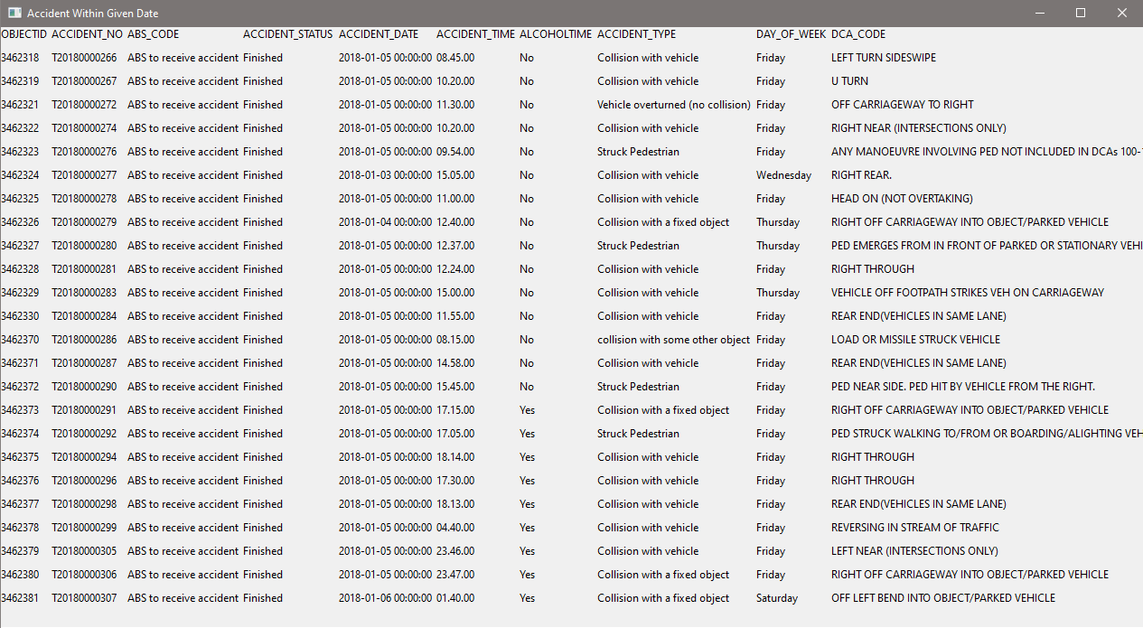 The system prints out a table containing all crash data from the date ranges 2018-01-01 to 2018-11-31. This data cannot be analyzed too much because it is currently very similar to crash data from other years. Further searches must be made.

# **Analysis 2 – The relationship between alcohol and light conditions**

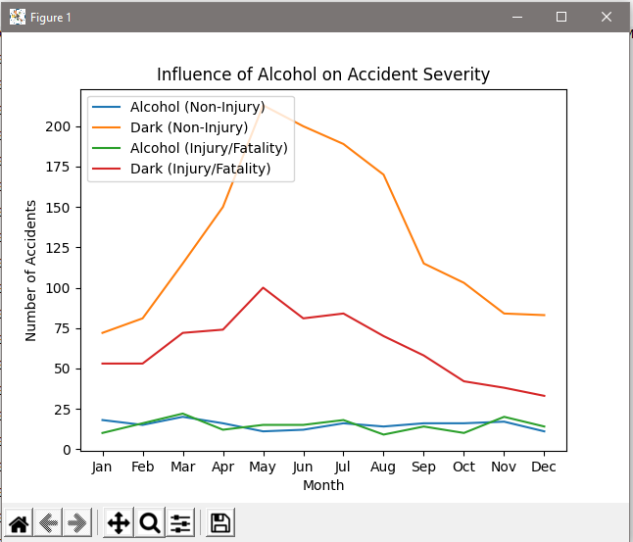

The search where alcohol is present in 2018 crashes presents a graph. This graph displays the number of accidents per month with different circumstances. It can be seen that much more accidents happen in the dark and therefore much more injuries occur. The variance between Injury vs non injury in the dark is much greater, meaning the types of crashes that occur in the dark are more unpredictable.

# **Analysis 3 – How many crashes involved animals**

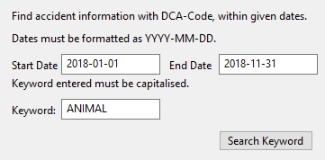

# **Analysis 4 – Relationship between passengers and accident severity**

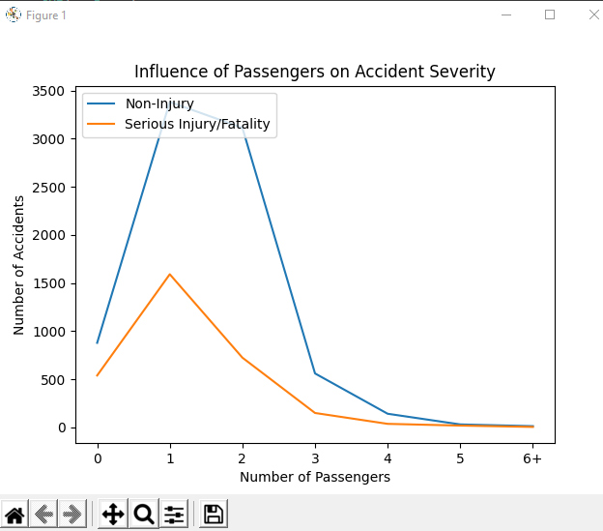

The number of accidents can be seen to greatly increase when one passenger is in the vehicle. But when there is more than one passenger, the number of accidents decreases. This could be due to factors like, more people in the car usually suggests a family and therefore safer drivers. The correlation between injury and non-injury is stable across the range of passenger numbers.